SRINIVAS UNIVERSITY
MANGALURU-575001, KARNATAKA (INDIA)

Research Centre for Neurorehabilitation
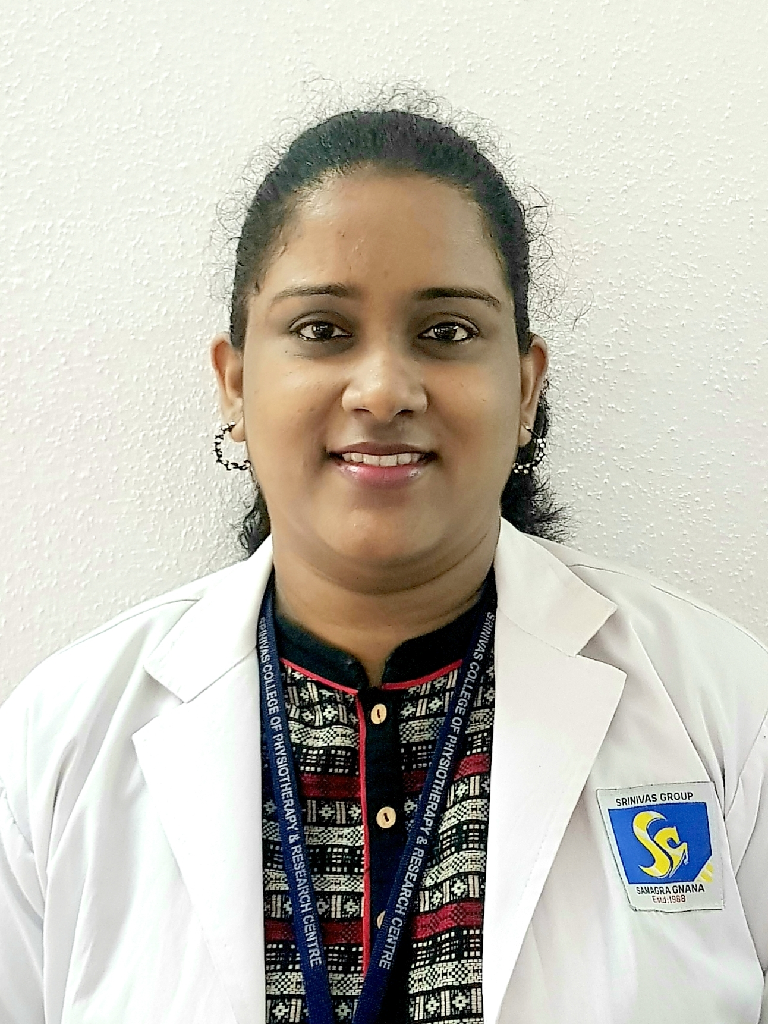
Dr. Thrishala Noronha (PT)
Research has always been an area of paramount importance to this centre. Many relevant areas in the field of Neurorehabilitation (NR) have witnessed significant developments over the last two decades. Nevertheless, there are still major challenges that neuroscientists need to address to achieve clinically-relevant results in this field. This Centre was established to embed research into clinical practice and focuses on the development and implementation of innovative health technologies, measurement tools, and interventions to improve health outcomes for people with neuropathology across their life span. This would be an attempt to build, define, apply, and share a robust evidence base for advanced Neurorehabilitation.
The vision of this Centre is to be recognized as a creative and innovative world class Research Centre and the mission is to increase the understanding of the rehabilitation potential of adults and children with acute and chronic neurological disorders by studying underlying motor control deficits and dysfunctions of neurological system. To fulfill this vision for research, the Centre has identified the following objectives:
- Promote rigorous research that is relevant to Neurorehabilitation.
- Develop and support existing and emerging research strengths within a "high performance culture" on assessments and interventions for individuals with various neuro-pathology like stroke, Parkinson’s disease, Diabetic Neuropathy, Spinal Cord Injury, TBI, Multiple sclerosis, etc.
- Facilitate multidisciplinary research excellence.
- To build research capacity and capabilities through post-graduate programmes and the training of new researchers.
- To attract leading National & International scholars to interact with undergraduate and postgraduate students and academic staff within the University through conferences, symposiums, scholarly publications, workshops, teaching programs and exchanges and collaboration.
- Foster excellence and innovation in teaching in the field of Neurorehabilitation.

SEMINARS/WORKSHOPS/CONFERENCES CONDUCTED:
- “Research Methodology and Biostatistics” in January 2017.
- “Vestibular Rehabilitation- Current Concepts for Physiotherapists” in March 2018.
- National level conference on “Neurotrauma and Neurorehabilitation” in December 2019.
- A webinar on “Dizziness Dilemma: Differential Diagnosis and Clinical Decision Making” in June 2020.
- A webinar on “Setting functional rehabilitation goal based on neurological level of spinal cord injury” in April 2021.

PUBLICATIONS:
- Thrishala Noronha, Ilona Gracie DeSouza, Rathish Manickam. Substantial aspects of balance in patients with Diabetic Neuropathy: A Physical Therapist’s perspective. International Journal of Innovative Research in Medical Science 2016; 01(9):389-94.
- Thrishala Noronha, Anisha, Hiral Katakia. Prevalence of sensory processing disorder among school going children in North Eastern India. International Journal of Scientific Research 2020;9(7):1-4.

COMPLETED PAPERS/PROJECTS:
- Thrishala Noronha, Prameela P. Hubli. Comparison of motor and cognitive dual task gait training (MCDGT) and conventional gait training to improve dynamic balance and functional mobility in patients with chronic stroke: A randomized clinical trial.
- Thrishala Noronha, Prameela P. Hubli. Cross culture adaptation and reliability of kannada version of MMSE in patients with stroke.
- Thrishala Noronha, Prameela P. Hubli. Intra and inter rater reliability of smart phone based application- Clinometer to assess trunk proprioception in patients with stroke.
- Thrishala Noronha, Radhika Gopal S. Correlation between environmental barriers and quality of life in chronic stroke: A cross sectional study.
- Thrishala Noronha, Radhika Gopal S. Correlation between texture discrimination ability in sole of foot and dynamic balance in patients with stroke: A cross sectional study.
- Thrishala Noronha, Radhika Gopal S. Normative data for median and ulnar nerve conduction and F wave among healthy individuals of Dakshina Kannada, Karnataka.
- Thrishala Noronha, Prameela P. Hubli, Radhika Gopal S. The brief Kinesthesia test for assessing kinesthesia in subjects with stroke: A reliability study.
- Thrishala Noronha. Robot assisted training for upper limb after stroke: A literature review.

ONGOING PROJECTS:
- Thrishala Noronha, Prajna Rao. Reliability and Validity of Monofilament Test for light touch sensation on Upper Limb in patients with Stroke.
- Thrishala Noronha. Vestibular rehabilitation in stroke: A narrative review.
- Thrishala Noronha. Neuroplasticity and stroke rehabilitation: A literature review.

